**CCT College Dublin**

**Assessment Cover Page**

|  |  |
| --- | --- |
| **Module Title:** | *Hdip DA for Business* |
| **Assessment Title:** | Integrated Machine Learning for Business and Data Visualization CA2 |
| **Lecturer Name:** | James Garza/Sam Weiss |
| **Student Full Name:** | Priya Arvind |
| **Student Number:** | sbs23062 |
| **Assessment Due Date:** | 26 November 2023, 11:59 PM |
| **Date of Submission:** | November 26th |

**Declaration**

|  |
| --- |
| By submitting this assessment, I confirm that I have read the CCT policy on Academic Misconduct and understand the implications of submitting work that is not my own or does not appropriately reference material taken from a third party or other source. I declare it to be my own work and that all material from third parties has been appropriately referenced. I further confirm that this work has not previously been submitted for assessment by myself or someone else in CCT College Dublin or any other higher education institution. |

Index

Introduction 1

Objectives 2

Part 1: Forecast monthly Australian beer production for the year 1996 using Time Series 3

• About the Dataset Dimensions 3

• Source 3

• Data Preparation 3

• Data Understanding 3

• Modelling 6

• Forecasting 7

• Evaluation 7

• Conclusion 8

Part 2: Text Analysis on the real-world data set - 30 Top Social Media REDDIT posts on “Jobs” topic. 8

• Source 8

• Conclusion 10

Part 3: Data Visualization -Interactive Dashboard 10

References 16

# Introduction

This project focused on the application of Time series analysis using Machine Learning modelling and application of Text analysis using Machine Learning modelling on - REDDIT social media posts and analyse and predict the sentiments.

Design and create an interactive dashboard using the chosen dataset “Ireland new property housing prices” from data.gov.ie. This report covers the different stages of the project, including data understanding, data preparation, data visualization and machine learning implementation and evaluation.

Overall, this project allowed me to apply my skills in data visualization and machine learning to a real-world problem.

# Objectives

In the below Project:

* We discuss the concept and application of Time series analysis using machine learning modelling on monthly data of Australian beer production for the year 1996 using Box-Jenkins model-SARIMA and forecasts the last 10 observations.

**Data Source**: ( <https://www.kaggle.com/sergiomora823/monthly-beer-production>)

* Apply Text analysis on the real-world data set - 30 Top Social Media REDDIT posts on “Jobs” topics using machine learning modelling and categories and predict the sentiments of the Social Media Post.
* Design and create an interactive dashboard using real-time dataset for Ireland's new property housing prices from data.gov.ie

**Data Source**: <https://data.gov.ie/dataset/annual-new-property-prices/resource/a169d257-3167-4a52-9c6a-c01344e8dc2d>

We have set a few objectives for this assignment:

* Application of Time series analysis on the dataset.
* Augmented Dickey-Fuller test to check the stationary and trend of the dataset.
* Application of Jenkins model- SARIMA to the Monthly beer production dataset.Checked for the model adequacy.
* Forecasts the last 10 observations.
* Determined the forecast errors, and made a time series plot of the data.
* Illustrated the auto-correlation and partial auto-correlation (PA)
* Collect 30 Top Social Media posts -REDDIT posts on Jobs Topic using API’s.
* Apply Text analysis on the real-world data set - REDDIT social media posts using machine learning modelling.
* Categories and predict the sentiments of the Social Media Posts.
* Design dashboard using real-time dataset for Ireland's new property housing prices from data.gov.ie
* Create a wireframe proposing the design of the dashboard before implementation.
* Create an interactive dashboard -include at least three rows and two columns for a total of six sections.
* The dashboard will be designed to be interactive, allowing the users to filter and explore the data in more detail

## **Part 1: Forecast monthly Australian beer production for the year 1996 using Time Series**

Application of Time series analysis using machine learning modelling on monthly Australian beer production for the year 1996 and explain the purpose of the Augmented Dickey-Fuller test in time series and using Box-Jenkins model- SARIMA, forecasts the last 10 observations.

* **About the Dataset Dimensions**

The dataset contains 2 features ‘Month’ -DateTime type and ‘Monthly beer production’ with a total of 476 rows.

* **Source**

( <https://www.kaggle.com/sergiomora823/monthly-beer-production>)

* **Data Preparation**
* Converted Month Column to datetime format.
* Renamed "Monthly beer production” column name to “Beer_Production”.

The goal of this exercise is to predict Australian beer production for the year 1996.

The data supplied consists of only one (endogenous) variable.

This makes it an auto-regressive problem, so we have to tackle it with the proper Model.

* **Data Understanding**
  + Converted Month Column to date-time format.
  + Renamed "Monthly beer production” column name to “Beer_Production”.
  + When we look closely into our data,we can clearly see that there is some annual seasonality.
  + Several features are obvious. 1) the time series is not stationary (Augmented Dickey-Fuller test used later).
  + Overall Observations- there has been a regime change from upward trending to lightly downward trending.
  + The volatility seem to increase in time.
  + Running adfuller on the beer production column returns the following values in order : (ADF Test Statistic, p-value, No. of Lags Used, No. of Observations Used,{Critical Values},icbest).The adfuller test returned a p-value of 0.178. We can assume that the data is stationary only if the p-value is very low (less than 0.05).
  + We could perform some transformation, differencing, smoothing, outlier deletion, or removal of old data.The choice for a seasonality period in this type of problem is straightforward and we set is as 12 - the number of months in one period (year).
  + To achieve stationarity, we difference the production data by twelve months and check the p-value using the adfuller test.



* + As suspected,some annual seasonality is present since the p-value has reduced below 0.05 for 12 months difference. Hence we can assume stationarity when differencing by 12 months.





* For an AR model, the theoretical PACF “shuts off” past the order(p) of the model.
* For an MA model, the theoretical PACF does not shut off, but instead tapers toward 0 in some manner. A clearer pattern for an MA model is in the ACF. The ACF will have non-zero auto-correlations only at lags involved in the model.
* **Modelling**

SARIMA is the model of choice, since it allows for seasonality and trend modelling.  
  
Analysis of ACF or PCF, which don’t provide definitive parameters for SARIMA, only a guidance to start a parameter grid search.

* SARIMA combining auto-regressive integrated moving average model with the same for seasonality gives us the best chances.
* Since our data is not an ideal case of the ARIMA model, the trend is not clearly visible. We will take p,d,q values as (1,1,1) and seasonal factor as 12 (for SARIMA model)



* **Forecasting**

These predictions underestimate the real-life performance of the model since as new data arrives we have the ability to spot any new trend or extreme changes and retrain/adjust our modelling strategy.  


* **Evaluation**

From visual analysis, we can see that the SARIMA model performed reasonably well. However, to understand the accuracy of the model mathematically, we can calculate the residual, mean absolute per cent error and root mean squared error are not high as expected after Grid search on the hyper parameters. Also, the Model shows an Overfitted Accuracy Score.



* **Conclusion**
  + - * We do not know the unit of production so it is hard to make any concrete remarks on it from the baseline metrics
      * However, from the plots, it appears that there was no big change in the production of beer in 1996 and it is very similar to the previous years
      * Maybe there are other parameters that influence the beer production (e.g. temperature, humidity etc.) - which are not considered here.

## **Part 2: Text Analysis on the real-world data set - 30 Top Social Media REDDIT posts on “Jobs” topic.**

Apply Text Analysis on the real-world data set - 30 Top Social Media REDDIT posts on “Jobs” topic using machine learning modelling and categories and predict the sentiments of the Social Media Post.

* **Source**
* We downloaded the Top 30 Social Media Posts from the Reddit website using API from PRAW Library.
* 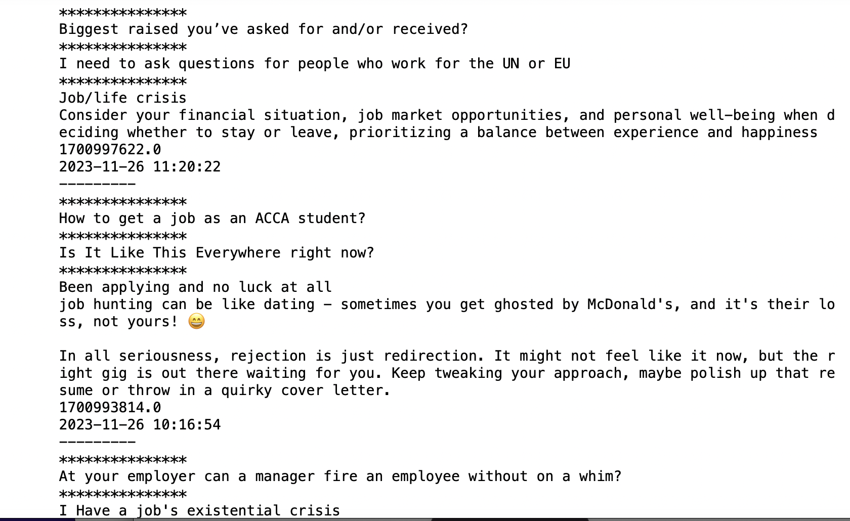
* Segregated the Posts into a dataframe with Posts body as ‘Posts Title’ column and ‘Posts time ‘ column as Posts timestamp.
* When we look closely into our data, we can clearly see that there are few punctuation marks and frequent non-relevant words for our analysis.
* Using word_tokenize, RegexpTokenizer and nltk libraries, tried to feature extraction with key works from Positive posts.
* We removed all Stop words including the most frequent word from the word cloud like guys, Pre, good, need, help etc.
* We segregated the words into SentimentIntensityAnalyzer with a compound score threshold of 0.1.



* Any word having a compound score less than 0.1 is classified as a negative word, equal to 0.1 is classified as a neutral word and greater than 0.1 compound score is classified as a Positive word.



* + With Every new feed of posts neutral words are more as compared to positive and negative word.
  + The MultinomialNB model is fitting on posts and tries to predict the sentiments of the Posts.

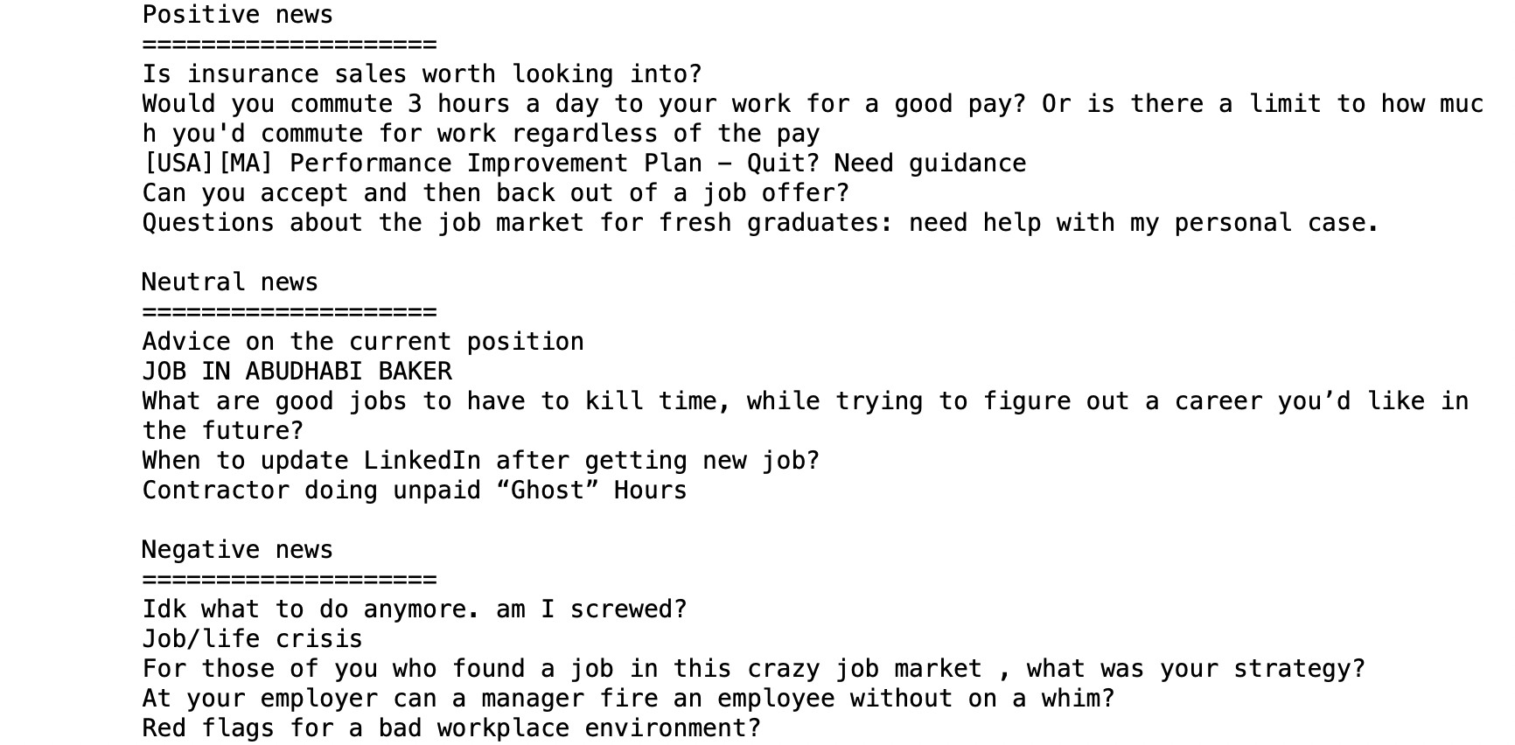

* **Conclusion**
  + Overall we did a good understanding of Text Analysis and were able to categorize whether the social media posts were positive posts or not.
  + Also, we were able to extract particular Positive/Negative posts with keywords.
  + We were also able to predict word sentiments using the MultinomialNB Machine learning Model.

## **Part 3: Data Visualization -Interactive Dashboard**

Prior to 1974 the data was based on surveys of existing house sales in Dublin carried out by the Valuation Office on behalf of the D. O. E.

**Source:** <https://data.gov.ie/dataset/annual-new-property-prices/resource/a169d257-3167-4a52-9c6a-c01344e8dc2d>

**Dataset:** URL: <https://opendata.housing.gov.ie/dataset/bf577a62-ac29-4d02-b7f2-b450f7b6cb60/resource/a169d257-3167-4a52-9c6a-c01344e8dc2d/download/form_41a-price-new-property-area-by_year_2.csv>

**Data understanding:**

* + Since Data was based on the surveys collected, Data preparation was a major task to convert Raw data into a usable dataframe.
  + There were 93 Rows with 13 Columns and many columns were unnamed.
  + All NAN values / missing values were removed from the analysis since our goal is to Create a dashboard which will briefly describe the dataset, its provenance and domain, and a summary of the key insights derived from the exploratory data analysis.

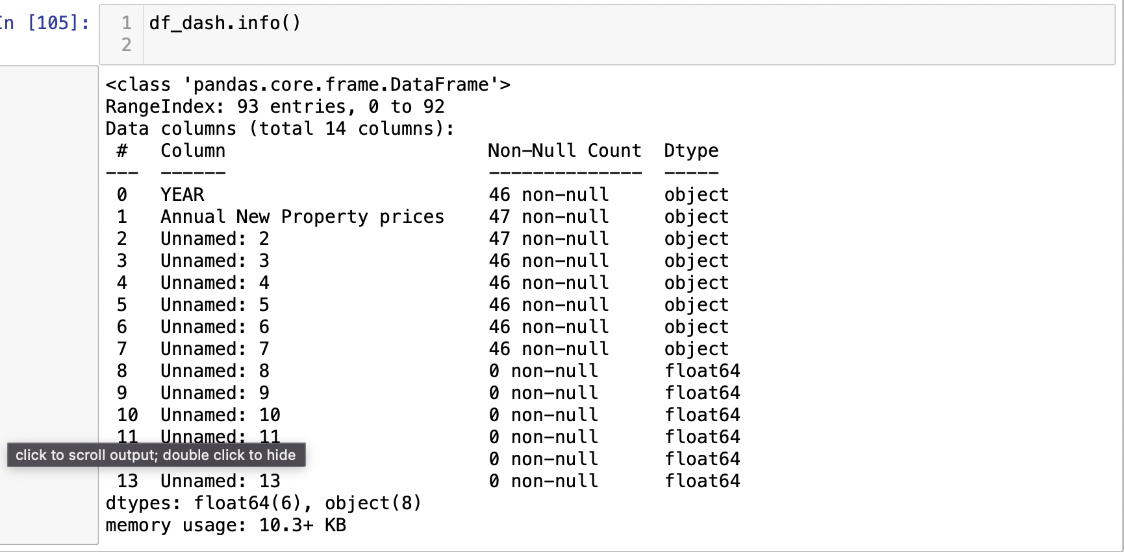

**Data Preparation:**

* + We removed all the headers and derived column names from First Row which had all the valid column names like Location name, House property price etc.
  + Also I renamed few columns which had white space in the column name since this was creating issues while processing the data.
  + We removed ‘,’ from numerical values and converted it to the respective datatype like Int for Years and Float for Housing Prices.
  + All NAN values / missing values and unnamed Columns were removed from the analysis.
  + Converted all Location Columns like Dublin, Cork etc under one new Column called Locations using Pandas Melt functions.

**Dashboard Wireframe**

* + Since, our goal is to Create a dashboard which will briefly describe the dataset, its provenance and domain, and a summary of the key insights derived from the exploratory data analysis.
  + Our focus was on 3 Features ‘Years’,’ Location’ and ‘Housing Price’.
  + Panel -1st Row with 2 Columns will Showcase overall Housing Prices for each Location with respect to years. we used an Interactive Scatter Plot with a year’s value that can be selected from the scroll bar and a static Box plot will showcase any outliers in the Housing Values.
  + Panel -2nd Row with 2 Columns will Showcase Housing Prices for each Location and Housing property value fluctuations over the decade or years for better comparison. We used an Interactive Line Plot with Locations that can be selected from the drop-down and static bar graph to view the Housing property value fluctuations over the decade.
  + Panel -3rd Row with 2 Columns will Showcase Particular features that can be compared with each other. We used an Interactive Scatter Plot with any 2 features and a static plot will showcase the Top 3 Housing Property price locations per decade.

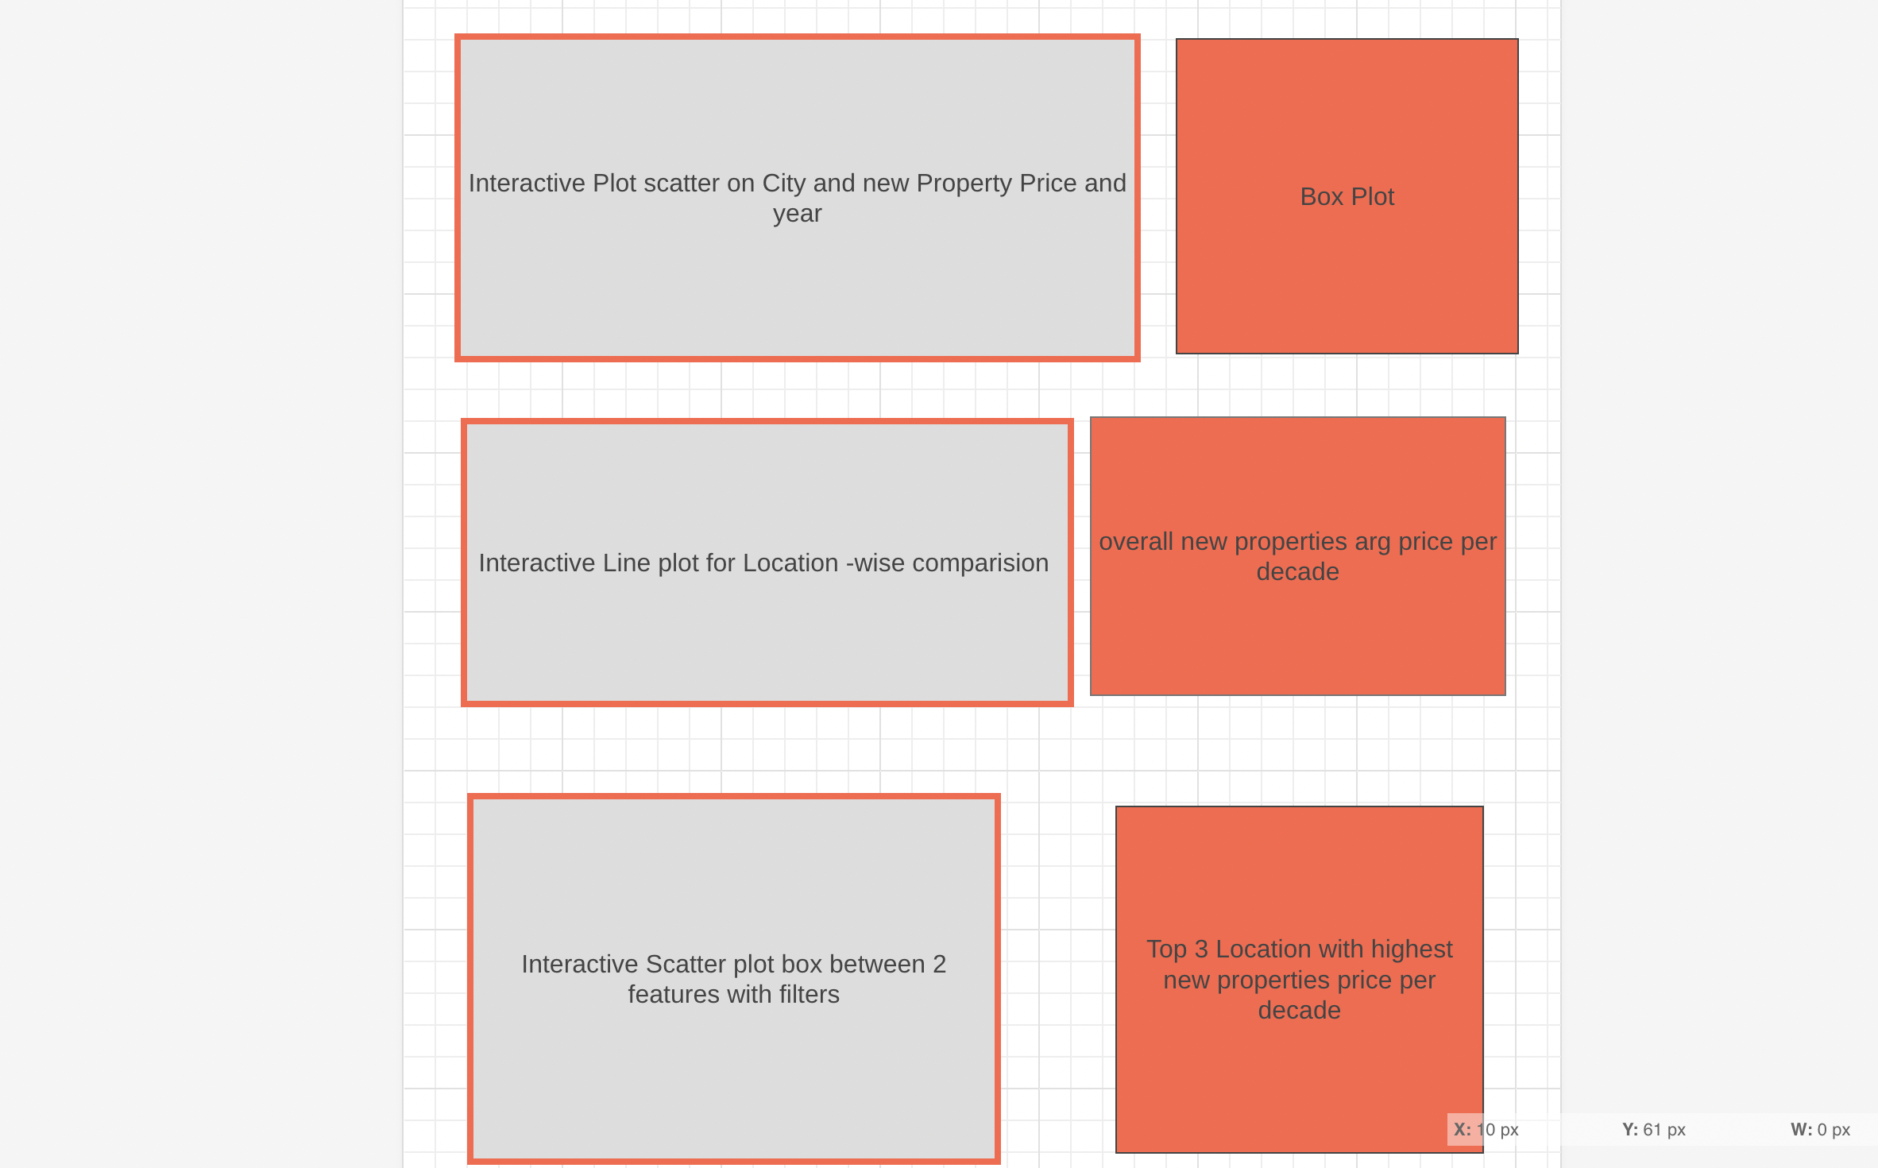

**Dashboard Plots :**

* + Panel -1st Row with 2 Columns will Showcase overall Housing Prices for each Location with respect to years. we used an Interactive Scatter Plot with a year’s value that can be selected from the scroll bar and a static Box plot will showcase any outliers in the Housing Values.

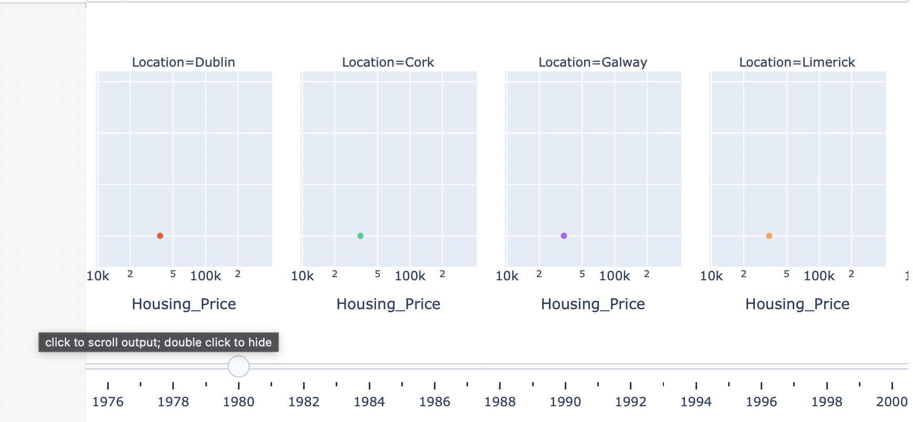

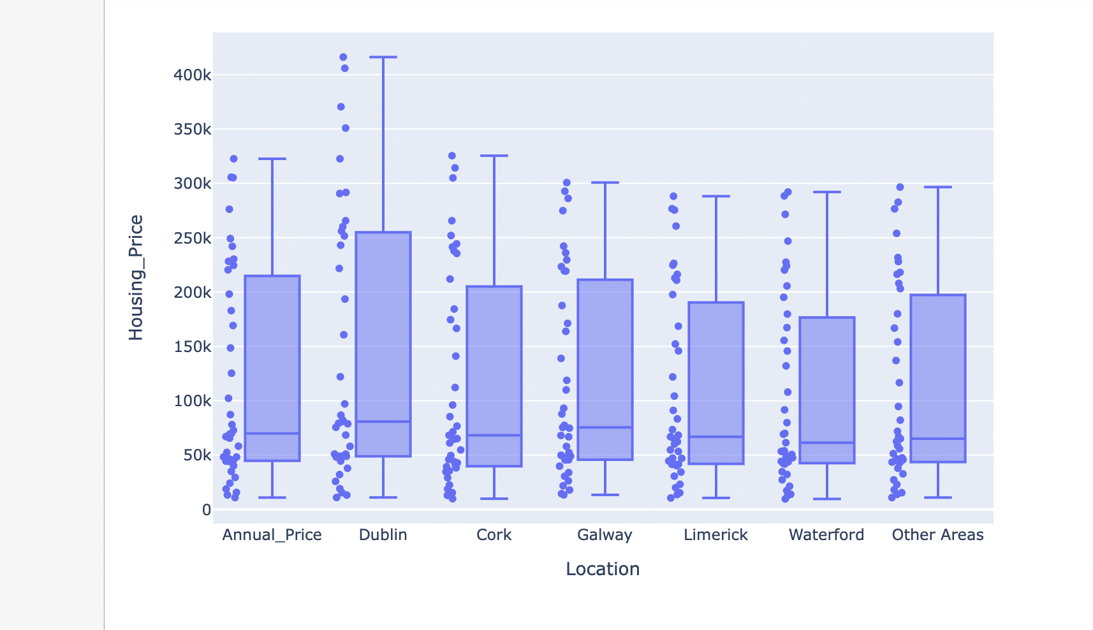

* + 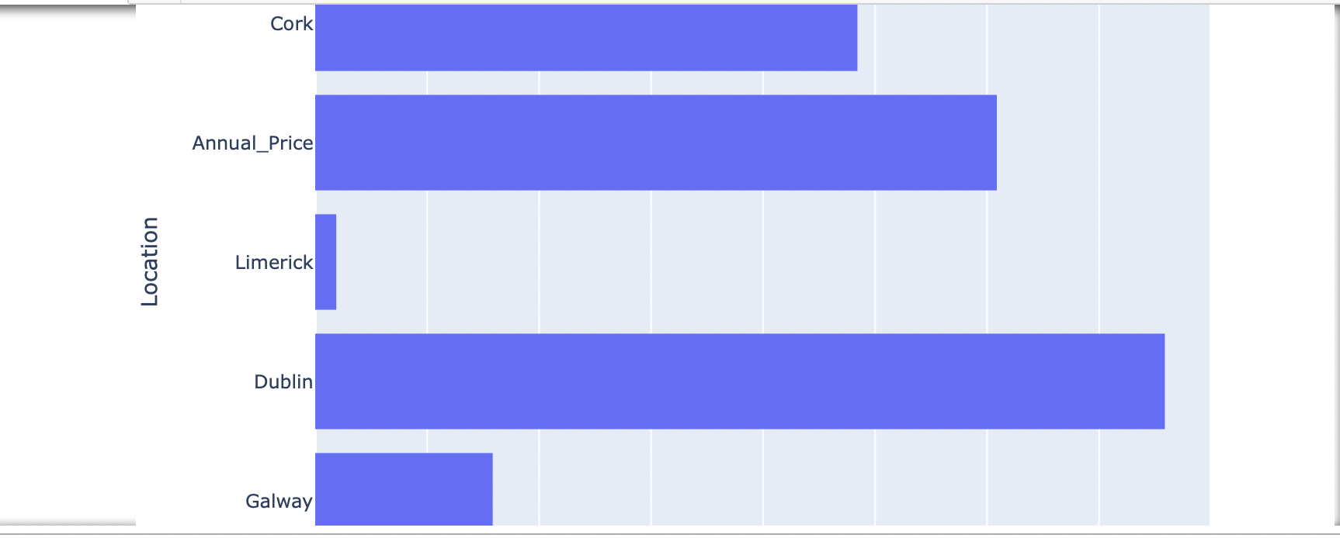Panel -2nd Row with 2 Columns will Showcase Housing Prices for each Location and Housing property value fluctuations over the decade/years for better comparison. We used an Interactive Line Plot with Locations that can be selected from the drop-down and static bar graph Housing property value fluctuations over the decade.

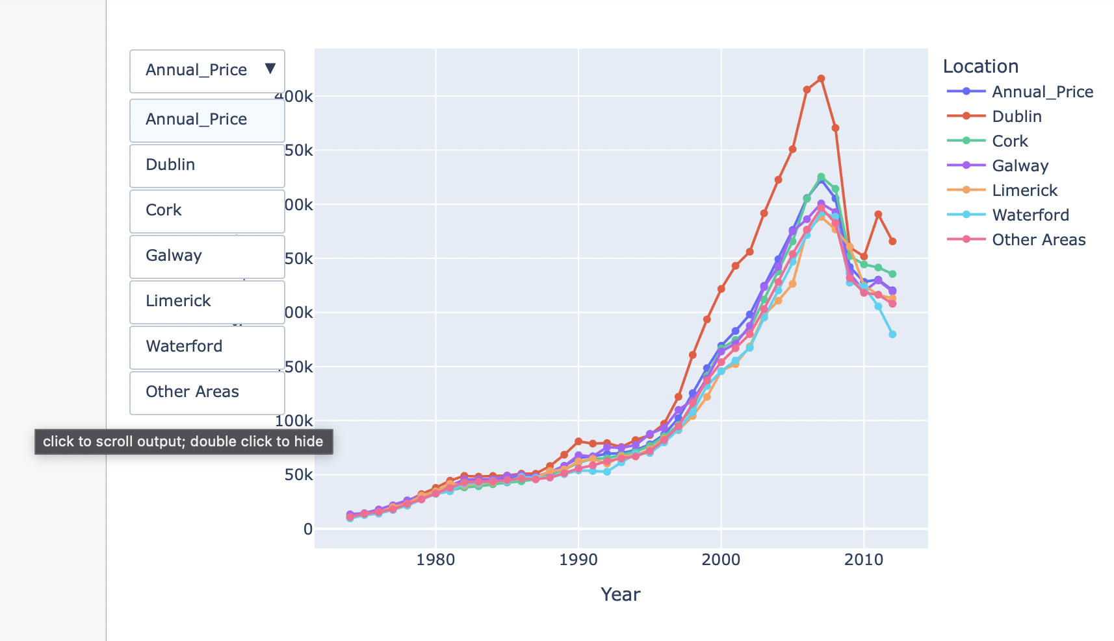

* + Panel -3rd Row with 2 Columns will Showcase Particular features that can be compared with each other. We used an Interactive Scatter Plot with any 2 features and a static 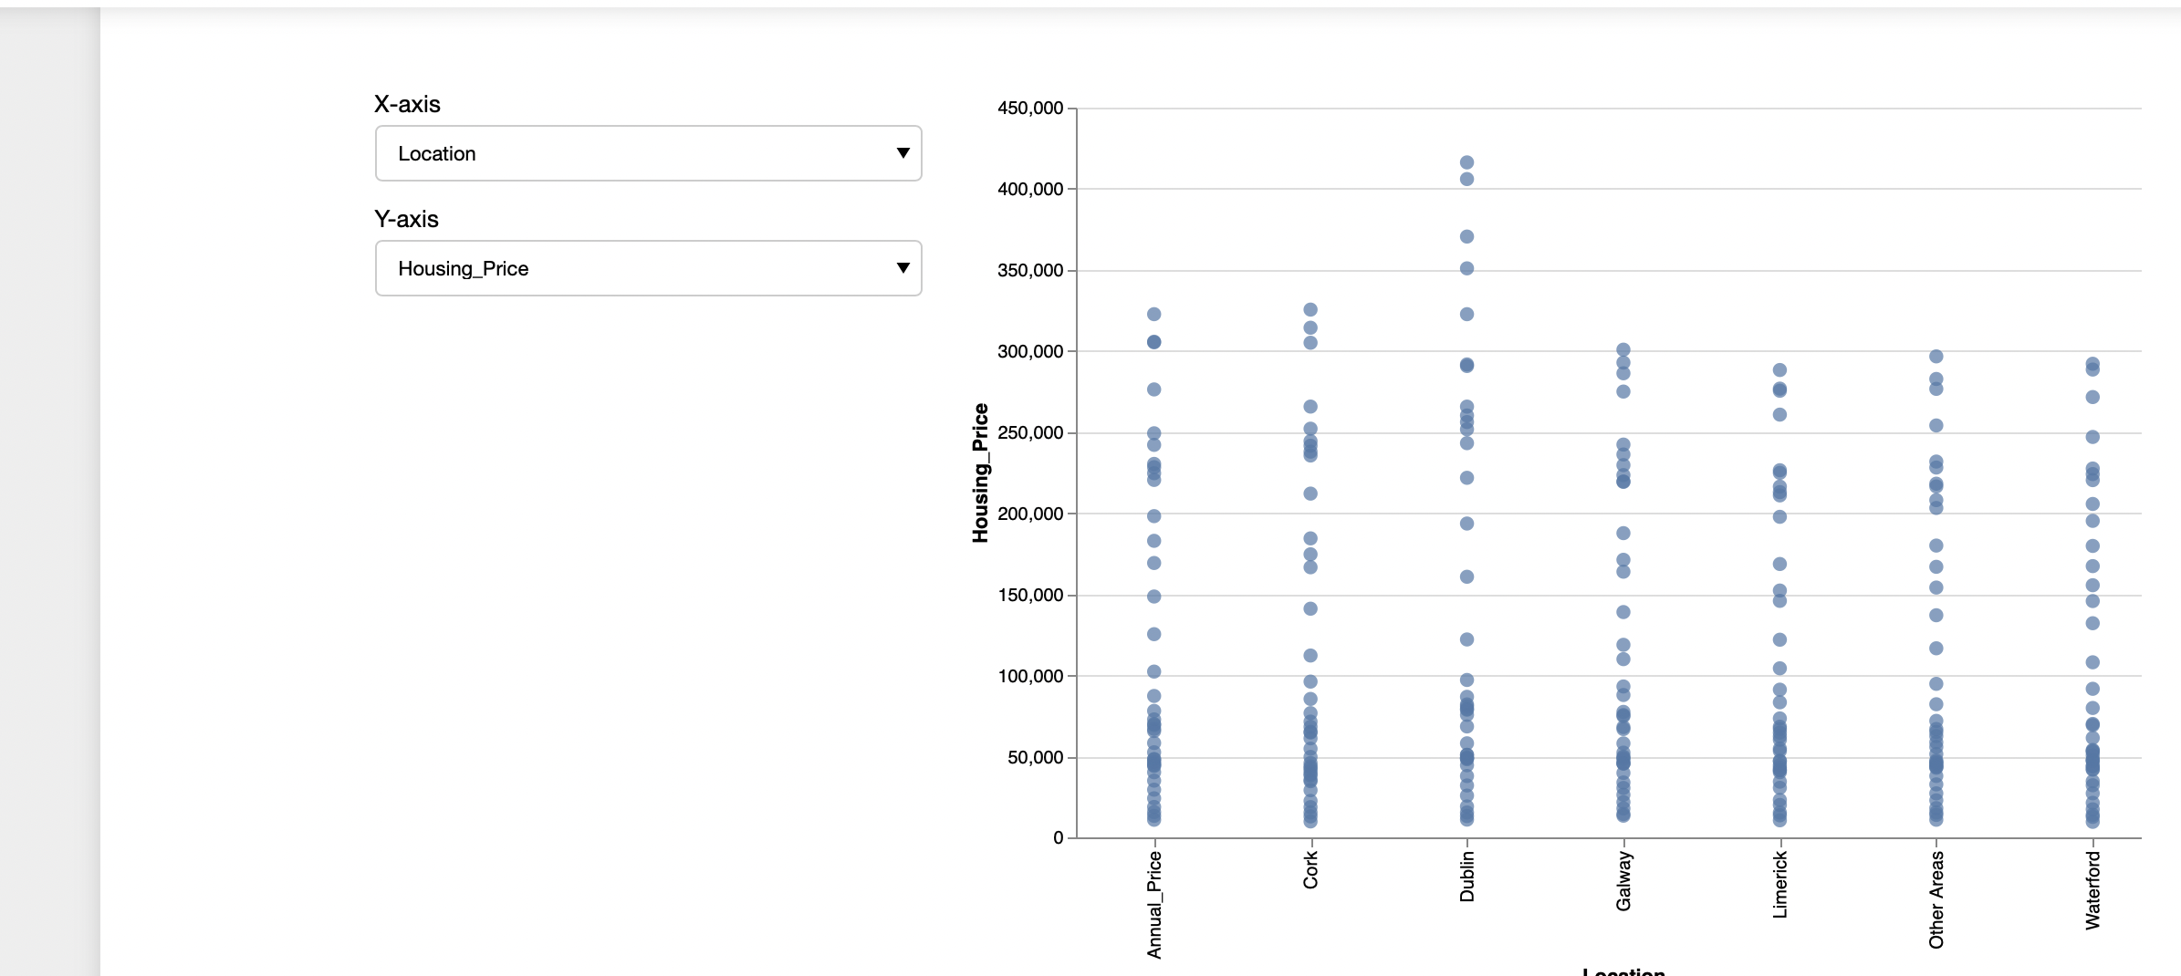plot will showcase the Top 3 Housing Property price locations per decade.

**Conclusion:**

* Overall we learned to design a Dashboard and create many useful interactive plots which will briefly describe the dataset, its provenance and domain, and a summary of the key insights derived from the exploratory data analysis.

# **References**

1. *Determine stock volatility with Candlestick charts and Tableau* (no date) *Tableau*.

Available at: https://www.tableau.com/en-gb/solutions/gallery/stock-charts?d=7013y000002aJI7AAM&utm_campaign=Prospecting-CORE-ALL-ALL-ALL-ALL&utm_medium=Paid%2BSearch&utm_source=Google%2BSearch&utm_campaign_id=2017049&utm_language=EN&utm_country=UKI&adgroup=&adused=STAT&creative=&gclid=CjwKCAiA9ourBhAVEiwA3L5RFj1O5tTNuP8JYKWTuy-YXRlBKJVbd19QnJ0LwBNm1IyelkAWywmrxhoC3BsQAvD_BwE&gclsrc=aw.ds (Accessed: 26 November 2023).

*2.Determine stock volatility with Candlestick charts and Tableau* (no date) *Tableau*. Available at: https://www.tableau.com/en-gb/solutions/gallery/stock-charts?d=7013y000002aJI7AAM&utm_campaign=Prospecting-CORE-ALL-ALL-ALL-ALL&utm_medium=Paid%2BSearch&utm_source=Google%2BSearch&utm_campaign_id=2017049&utm_language=EN&utm_country=UKI&adgroup=&adused=STAT&creative=&gclid=CjwKCAiA9ourBhAVEiwA3L5RFj1O5tTNuP8JYKWTuy-YXRlBKJVbd19QnJ0LwBNm1IyelkAWywmrxhoC3BsQAvD_BwE&gclsrc=aw.ds (Accessed: 26 November 2023).

*3.Plotly* (no date) *Plotly express in Python*. Available at: https://plotly.com/python/plotly-express/ (Accessed: 26 November 2023).

4.Andreshg (2021) *Timeseries analysis* , *Kaggle*. Available at: https://www.kaggle.com/code/andreshg/timeseries-analysis-a-complete-guide (Accessed: 26 November 2023).

*5.Determine stock volatility with Candlestick charts and Tableau* (no date) *Tableau*. Available at: https://www.tableau.com/en-gb/solutions/gallery/stock-charts?d=7013y000002aJI7AAM&utm_campaign=Prospecting-CORE-ALL-ALL-ALL-ALL&utm_medium=Paid%2BSearch&utm_source=Google%2BSearch&utm_campaign_id=2017049&utm_language=EN&utm_country=UKI&adgroup=&adused=STAT&creative=&gclid=CjwKCAiA9ourBhAVEiwA3L5RFj1O5tTNuP8JYKWTuy-YXRlBKJVbd19QnJ0LwBNm1IyelkAWywmrxhoC3BsQAvD_BwE&gclsrc=aw.ds (Accessed: 26 November 2023).

*6.Plotly* (no date) *Plotly express in Python*. Available at: https://plotly.com/python/plotly-express/ (Accessed: 26 November 2023).